FOR IMMEDIATE RELEASE

Armchair Generals Team Up with DavidDance to Present New Free Soulful House and Dance Music Download

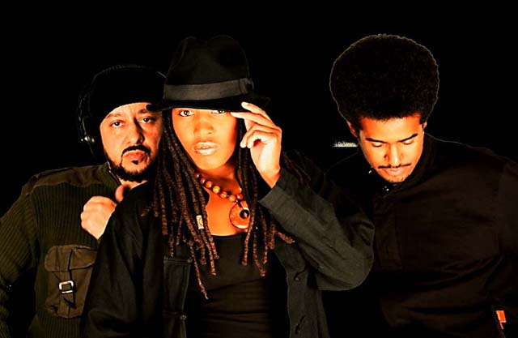LONG BEACH, Calif. (November 8, 2011) − Exclusively for their fans, Long Beach-based indie band Armchair Generals (http://www.armchairgeneralsmusic.com) will release a free soulful house and dance music download from their upcoming album “The Jet Sect” on November 25. In the music genres of soulful house, dance and drum n bass, “Let It Go” will be the first single released from the album set to debut on the Italian music label DavidDance in January 2012.The band ensures everyone in the AG community, including their social network of Facebook fans, Twitter followers and 562 City Lifers, will have the first opportunity to hear the new single before its official release.

Armchair Generals will receive digital worldwide distribution on the DavidDance record label which focuses on electronic dance, house, lounge music and more. The newly formed partnership with DavidDance proves to be an exciting opportunity for the self-promoting band, which looks forward to the distribution push after an initial launch from SolShock Publicity, long hauls of DIY PR, and live intimate performances throughout Los Angeles. Their 2010 self-titled EP; “The Armchair Generals” is currently distributed by DavidDance, with exclusive remixes on http://www.beatport.com/release/daydreamer/404386. Songs including” Day Dreamer”, “Sunday Morning”, and “Clear” are receiving glowing feedback and rave reviews from producers and internet radio DJs around the world.

“A great mix of soulful expressions and emotive organic rhythms,” said Marc LaCasse, “The subtle touches of soul and electronic are just the icing on the cake.”

The Armchair Generals have recently partnered with Altitude Media Inc. to premier their entire 2010 EP on US Airways flights. Along with an interview with the band’s lead vocalist and bassist Pernicia Jaye, Armchair Generals music will be heard on over 3,000 national and international US Airways flights with a potential to reach over 600,000 passengers throughout November and December.

The independent artists from Long Beach were recently nominated for two SoulTracks 2011 Readers' Choice Awards in the categories of Best Duo or Group and Best New Artists. Fans are encouraged to stay tuned for the band’s upcoming profile on Bandcamp.

About Armchair Generals:
Formed in 2006, the Armchair Generals are a fast-emerging independent band from Long Beach, CA boasting an infectious mix of soulful house, dance, down tempo and electronic music. Their live performances are exciting, cozy and inclusive with a unique ambiance that loyal fans love. The band has released three albums since 2007 which are currently available on iTunes and CD Baby. They’ve been featured on Fusicology’s “What Is Good Music” compilation CD (October 2010) and have received notable media coverage from local print and online media including Live Long Beach Magazine, Uptown Gazette Newspaper, LB Post.com, Nu-SoulMag.com, SoulTracks.com, and more. Hear music and learn more at www.armchairgeneralsmusic.com .
END

